CRICKET STATISTICS

TEAM NAME: dmql_ks

TEAM MEMBERS:

Member 1: Karan Shah UB id: kshah23

Member 2: Saqlain Naveed Ahmed UB id: sahmed34

Problem Statement:

Cricket is a game whose popularity has grown leaps and bounds in the past few decades. Naturally with each passing year the game keeps evolving and has brought much interest in the field of statistical analysis and machine learning. Keeping this in mind we propose to make a database system which consists of statistics related to the three formats of the game namely, Test, One-Day International and Twenty-20 which could be used in the field of research in the game. The volume of data that we are considering for the database is huge as it includes not only the current players but also the players of past generations. To use this large volume of data, the usage of excel sheets would not be efficient and would also become unmanageable. Also, we plan to combine data from multiple tables and gather statistics on them through joins which would have been an arduous task through excel sheets. The database that we propose considers the batting and bowling statistics separately for all the three formats for which we have six tables to represent respectively. We also have a table that only includes the details of the player and the country he represents to tackle redundancy. We propose to run a complex set of queries on the database that involves joins, aggregations and group-by clauses. The data updates happen on each day when the game is played and the records of the players who have played gets updated.

Target User:

The database will primarily be used by cricket enthusiasts and people who want to conduct research in the field of sports or create models through machine learning to predict future outcomes. The database administrator will be an official from cricket’s international governing body ICC (International Cricket Council)

Designing the Database schema:

To represent a relational schema, we first present E/R diagrams

Each Entity from the above diagram is represented below with its attributes.

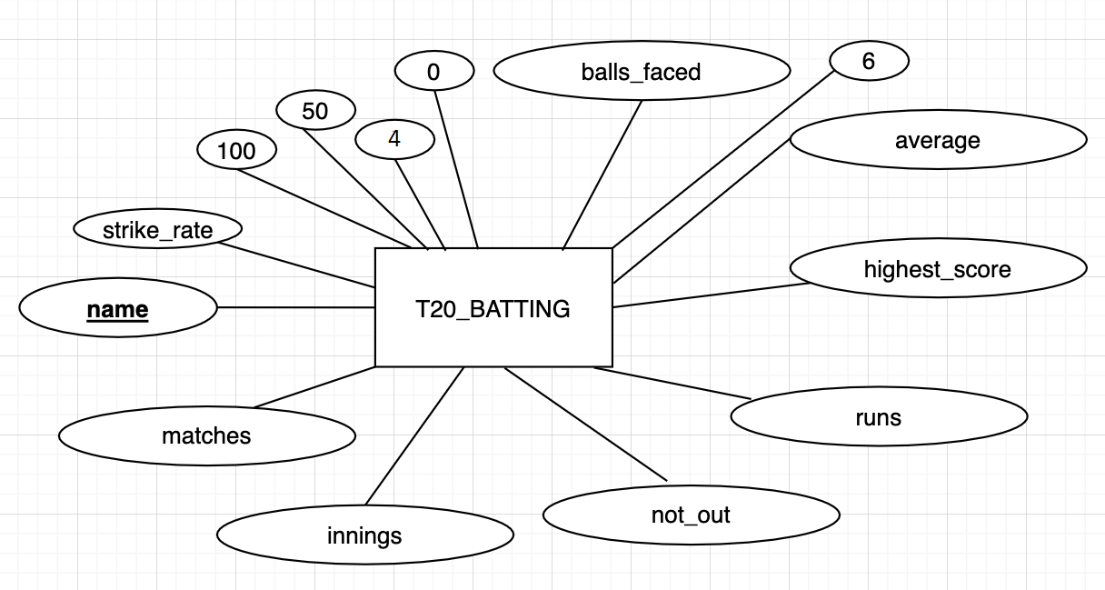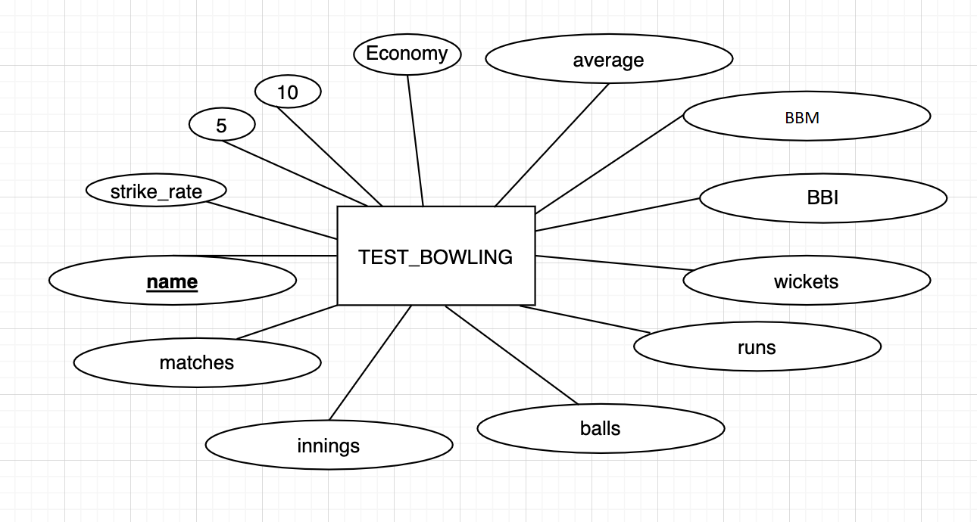

Tables included:

**PLAYER**

Description: This table stores the names of the cricket players and the country which they have represented.

| PLAYER | | | | |
| --- | --- | --- | --- | --- |
| Column Name | Pk | Null | Data Type | Description |
| NAME | 1 | No | VARCHAR (100 BYTE) | Name of the cricket player. |
| COUNTRY |  | No | VARCHAR (100 BYTE) | Country the player has represented. |

**TEST_BATTING**

Description: This table stores the batting statistics of players in test cricket.

| TEST_BATTING | | | | |
| --- | --- | --- | --- | --- |
| Column Name | Pk | Null | Data Type | Description |
| NAME | 1 | No | VARCHAR (100 BYTE) | Name of the cricket player. |
| MATCHES |  | No | INT | Number of matches played. |
| INNINGS |  | No | INT | Number of innings, player has batted. |
| NOT_OUT |  | No | INT | Number of times the player has not got out. |
| RUNS |  | No | INT | Total number of runs, player has scored. |
| HIGHEST_SCORE |  | No | CHAR (5 BYTE) | Player’s highest score. |
| AVERAGE |  | No | REAL | Batting average. |
| ZEROES |  | No | INT | Number of ducks players got out. |
| FIFTIES |  | No | INT | Number of Half-centuries the player has scored. |
| HUNDREDS |  | No | INT | Number of centuries the player has scored. |

**ODI_BATTING**

Description: This table stores the batting statistics of players in One-day International cricket.

| ODI_BATTING | | | | |
| --- | --- | --- | --- | --- |
| Column Name | Pk | Null | Data Type | Description |
| NAME | 1 | No | VARCHAR (100 BYTE) | Name of the cricket player. |
| MATCHES |  | No | INT | Number of matches played. |
| INNINGS |  | No | INT | Number of innings, player has batted. |
| NOT_OUT |  | No | INT | Number of times the player has not got out. |
| RUNS |  | No | INT | Total number of runs, player has scored. |
| HIGHEST_SCORE |  | No | CHAR (5 BYTE) | Player’s highest score. |
| AVERAGE |  | No | REAL | Batting average. |
| BALLS_FACED |  | No | INT | Number of balls faced. |
| ZEROES |  | No | INT | Number of ducks players got out. |
| FIFTIES |  | No | INT | Number of Half-centuries the player has scored. |
| HUNDREDS |  | No | INT | Number of centuries the player has scored. |
| STRIKE_RATE |  | No | REAL | Batting strike rate of the player. |

**T20_BATTING**

Description: This table stores the batting statistics of players in Twenty-20 International cricket.

| T20_BATTING | | | | |
| --- | --- | --- | --- | --- |
| Column Name | Pk | Null | Data Type | Description |
| NAME | 1 | No | VARCHAR (100 BYTE) | Name of the cricket player. |
| MATCHES |  | No | INT | Number of matches played. |
| INNINGS |  | No | INT | Number of innings, player has batted. |
| NOT_OUT |  | No | INT | Number of times the player has not got out. |
| RUNS |  | No | INT | Total number of runs, player has scored. |
| HIGHEST_SCORE |  | No | CHAR (5 BYTE) | Player’s highest score. |
| AVERAGE |  | No | REAL | Batting average. |
| FOURS |  | No | INT | Number of fours hit by a player. |
| SIXES |  | No | INT | Number of sixes hit by a player. |
| BALLS_FACED |  | No | INT | Number of balls faced. |
| ZEROES |  | No | INT | Number of ducks, players got out. |
| FIFTIES |  | No | INT | Number of Half-centuries the player has scored. |
| HUNDREDS |  | No | INT | Number of centuries the player has scored. |
| STRIKE_RATE |  | No | REAL | Batting strike rate of the player. |

**TEST_BOWLING**

Description: This table stores the bowling statistics of players in test cricket.

| TEST_BOWLING | | | | |
| --- | --- | --- | --- | --- |
| Column Name | Pk | Null | Data Type | Description |
| NAME | 1 | No | VARCHAR (100 BYTE) | Name of the cricket player. |
| MATCHES |  | No | INT | Number of matches played. |
| INNINGS |  | No | INT | Number of innings, player has played. |
| BALLS |  | No | INT | Number of balls, player has bowled. |
| RUNS_CONCEDED |  | No | INT | Total number of runs, player has conceded. |
| WICKETS |  | No | CHAR (10 BYTE) | Number of wickets, player has taken. |
| BBI |  | No | CHAR (10 BYTE) | Best bowling in innings. |
| BBM |  | No | CHAR (10 BYTE) | Best bowling in a Match. |
| AVERAGE |  | No | REAL | Bowling average. |
| ECONOMY |  | No | REAL | Runs conceded per over. |
| FIVE_WICKET_HAULS |  | No | INT | Total Number of 5-wicket hauls per innings |
| TEN_WICKET_HAULS |  | No | INT | Total number of 10-wickets hauls per match |
| STRIKE_RATE |  | No | REAL | Bowling strike rate |

**ODI_BOWLING**

Description: This table stores the bowling statistics of players in One-Day Internatinal cricket.

| ODI_BOWLING | | | | |
| --- | --- | --- | --- | --- |
| Column Name | Pk | Null | Data Type | Description |
| NAME | 1 | No | VARCHAR (100 BYTE) | Name of the cricket player. |
| MATCHES |  | No | INT | Number of matches played. |
| INNINGS |  | No | INT | Number of innings, player has played. |
| BALLS |  | No | INT | Number of balls, player has bowled. |
| RUNS_CONCEDED |  | No | INT | Total number of runs, player has conceded. |
| WICKETS |  | No | CHAR (10 BYTE) | Number of wickets, player has taken. |
| BBI |  | No | CHAR (10 BYTE) | Best bowling in innings. |
| AVERAGE |  | No | REAL | Bowling average. |
| ECONOMY |  | No | REAL | Runs conceded per over. |
| FOUR_WICKET_HAULS |  | No | INT | Total Number of 4-wicket hauls per innings |
| FIVE_WICKET_HAULS |  | No | INT | Total number of 5-wickets hauls per innings |
| STRIKE_RATE |  | No | REAL | Bowling strike rate |

**T20_BOWLING**

Description: This table stores the bowling statistics of players in Twenty-20 international cricket.

| T20_BOWLING | | | | |
| --- | --- | --- | --- | --- |
| Column Name | Pk | Null | Data Type | Description |
| NAME | 1 | No | VARCHAR (100 BYTE) | Name of the cricket player. |
| MATCHES |  | No | INT | Number of matches played. |
| INNINGS |  | No | INT | Number of innings, player has played. |
| BALLS |  | No | INT | Number of balls, player has bowled. |
| RUNS_CONCEDED |  | No | INT | Total number of runs, player has conceded. |
| WICKETS |  | No | CHAR (10 BYTE) | Number of wickets, player has taken. |
| BBI |  | No | CHAR (10 BYTE) | Best bowling in innings. |
| AVERAGE |  | No | REAL | Bowling average. |
| ECONOMY |  | No | REAL | Runs conceded per over. |
| FOUR_WICKET_HAULS |  | No | INT | Total Number of 4-wicket hauls per innings |
| FIVE_WICKET_HAULS |  | No | INT | Total number of 5-wickets hauls per innings |
| STRIKE_RATE |  | No | REAL | Bowling strike rate |